Project Report on
TELEPHONE SIMULATION SYSTEM


Submitted to
Department of Computer Science and Engineering
Nepal Engineering College

in Partial Fulfillment of the
Requirements for the Degree of B.E. in Computer
Submitted By
Aruna Thapa (021-311)
Submitted To : Ass Proff Santosh Bhattarai
Date: 25/01/2025

ABSTRACT
The Telephone Simulation System is designed to model and simulate the behavior of a telecommunications network, specifically focusing on call management and resource allocation. The system simulates various operations, such as call initiation, call progress, and call completion, while managing limited communication links. It tracks ongoing calls, monitors the availability of lines, and processes call requests based on the availability of resources. The system also handles scenarios like blocked calls due to resource unavailability and tracks the number of completed, blocked, and busy calls. Through a graphical user interface (GUI), the system allows real-time visualization of ongoing calls, their status, and network resources. The simulation is valuable for testing network performance, optimizing resource usage, and understanding the dynamics of telecommunication systems under varying loads.

ACKNOWLEDGEMENT
I would like to express my sincere gratitude to my lecturer Santosh Bhattarai for their constant guidance, encouragement, and support throughout the development of the Telephone Simulation System. Their expertise and invaluable feedback have greatly enhanced my understanding of telecommunication systems and programming concepts, which were pivotal in the successful completion of this project.
I also appreciate the resources and knowledge shared by Department of Computer Engineering that helped me gain the necessary skills and tools to develop this simulation.
Finally, I would like to thank my peers, friends, and family for their support and understanding during the course of this project.
This project would not have been possible without the invaluable contributions and encouragement of all those involved. Thank you!
TABLE OF CONTENETS
ABSTRACT i
ACKNOWLEDGEMENT ii
TOOLS USED: 1
OBJECTIVE: 1
LOST CALL SYSTEM 2
OUTPUT 12
DELAYED CALL SYSTEM 14
OUTPUT 24
CONCLUSION 25

TOOLS USED:
INTELLIJ WITH JAVA
OBJECTIVE:
TO SIMULATE A TELEPHONE CALL SYSTEM
THEORY: A telephone simulation system is a model that mimics the operations of a real-world telephone network to analyze performance, optimize traffic handling, and improve communication efficiency. It simulates various components such as call routing, signal transmission, network congestion, and user interactions. The system can be used to study call waiting times, dropped calls, bandwidth allocation, and the impact of network failures. Telephone simulation is crucial in telecommunications for testing new technologies, predicting system behavior under heavy loads, and optimizing network infrastructure before real-world implementation. It helps service providers enhance call quality, reduce costs, and improve customer satisfactionTelephone simulation is crucial in telecommunications for testing new technologies, predicting system behavior under heavy loads, and optimizing network infrastructure before real-world implementation. It also aids in developing algorithms for call management, load balancing, and fault tolerance. By using simulation, service providers can enhance call quality, reduce costs, and improve customer satisfaction while ensuring a reliable and scalable communication network.

LOST CALL SYSTEM
In a telephone simulation system, a lost call refers to a situation where an incoming call cannot be serviced because there are no available lines or channels to handle the call. This situation is common in systems where there is a fixed number of service channels, and the system does not allow for queuing of calls. When all channels are occupied, the incoming call is either blocked or lost.
Blocked Call:
A blocked call refers to a call that cannot be completed because all available communication channels or lines are in use. This typically occurs in systems where there is a finite number of service channels and no waiting queue for calls. When a call is blocked, it means that the caller is unable to connect to the intended party, and the call is either rejected or lost.
Busy Call:
A busy call occurs when the called party is currently on the phone or engaged in an active call. In this case, the call is not blocked at the network level but is unavailable due to the called party being occupied. The caller receives a busy signal, indicating that the line is engaged, and the caller must wait or retry the call later.

import javax. swing.*;
import java.awt.*;
import java.util.*;
import java.awt.image.BufferedImage;
import javax.imageio.ImageIO;
import java.io.File;
import java.io.IOException;
class TelephoneSimulationSystem extends JFrame {
private JTextField nextFromField, nextToField, nextLengthField, nextArrivalTimeField;
private JTextField lineField1, lineField2, lineField3, lineField4, lineField5, lineField6,
lineField7, lineField8;
private JTextField inUseField, clockField, processedField, completedField, blockedField,
busyField;
private JTextField fromField1, toField1, endField1;
private JTextField fromField2, toField2, endField2;
private JTextField fromField3, toField3, endField3;
private Queue<Call> callQueue = new PriorityQueue<>(Comparator.comparingInt(c ->
c.arrivalTime));
private LinksPanel linksPanel;;
public TelephoneSimulationSystem() {
initializeUI();
initializeCallQueue();
}
private void initializeUI() {
setTitle("Telephone Simulation System");
setSize(1100, 600); // Increased width to accommodate the links panel
setDefaultCloseOperation(JFrame.EXIT_ON_CLOSE);
setLayout(null);
JLabel headerLabel = new JLabel(" SIMULATION OF A TELEPHONE SYSTEM TO SHOW LOST CALL");
headerLabel.setFont(new Font("Arial", Font.BOLD, 24));
headerLabel.setForeground(Color.BLACK);
headerLabel.setOpaque(true);
headerLabel.setBackground(Color.WHITE);
headerLabel.setHorizontalAlignment(SwingConstants.LEFT);
headerLabel.setBounds(10, 10, 1200, 40);
add(headerLabel);
JButton nextStateButton = new JButton("Simulate");
nextStateButton.setBounds(10, 60, 120, 30);
nextStateButton.addActionListener(e -> handleNextStateButtonClick());
add(nextStateButton);
JPanel nextCallPanel = new JPanel(new GridLayout(4, 2));
nextCallPanel.setBorder(BorderFactory.createTitledBorder("Next Call"));
nextCallPanel.add(new JLabel("From:"));
nextFromField = new JTextField("1", 5);
nextFromField.setEditable(false);
nextCallPanel.add(nextFromField);
nextCallPanel.add(new JLabel("To:"));
nextToField = new JTextField("7", 5);
nextToField.setEditable(false);
nextCallPanel.add(nextToField);
nextCallPanel.add(new JLabel("Length:"));
nextLengthField = new JTextField("20", 5);
nextLengthField.setEditable(false);
nextCallPanel.add(nextLengthField);
nextCallPanel.add(new JLabel("Arrival Time:"));
nextArrivalTimeField = new JTextField("1057", 5);
nextArrivalTimeField.setEditable(false);
nextCallPanel.add(nextArrivalTimeField);
nextCallPanel.setBounds(500, 100, 250, 150);
add(nextCallPanel);
JPanel linesPanel = new JPanel(new GridLayout(8, 2));
linesPanel.setBorder(BorderFactory.createTitledBorder("Lines"));
lineField1 = new JTextField("0", 1);
lineField1.setEditable(false);
linesPanel.add(new JLabel("Line 1:"));
linesPanel.add(lineField1);
lineField2 = new JTextField("1", 1);
lineField2.setEditable(false);
linesPanel.add(new JLabel("Line 2:"));
linesPanel.add(lineField2);
lineField3 = new JTextField("0", 1);
lineField3.setEditable(false);
linesPanel.add(new JLabel("Line 3:"));
linesPanel.add(lineField3);
lineField4 = new JTextField("1", 1);
lineField4.setEditable(false);
linesPanel.add(new JLabel("Line 4:"));
linesPanel.add(lineField4);
lineField5 = new JTextField("1", 1);
lineField5.setEditable(false);
linesPanel.add(new JLabel("Line 5:"));
linesPanel.add(lineField5);
lineField6 = new JTextField("0", 1);
lineField6.setEditable(false);
linesPanel.add(new JLabel("Line 6:"));
linesPanel.add(lineField6);
lineField7 = new JTextField("1", 1);
lineField7.setEditable(false);
linesPanel.add(new JLabel("Line 7:"));
linesPanel.add(lineField7);
lineField8 = new JTextField("0", 1);
lineField8.setEditable(false);
linesPanel.add(new JLabel("Line 8:"));
linesPanel.add(lineField8);
linesPanel.setBounds(10, 150, 200, 300);
add(linesPanel);
JPanel linksInfoPanel = new JPanel(new GridLayout(2, 2));
linksInfoPanel.setBorder(BorderFactory.createTitledBorder("Links"));
linksInfoPanel.add(new JLabel("Max No.:"));
JTextField maxNoField = new JTextField("3", 1);
maxNoField.setEditable(false);
linksInfoPanel.add(maxNoField);
linksInfoPanel.add(new JLabel("In Use:"));
inUseField = new JTextField("2", 1);
inUseField.setEditable(false);
linksInfoPanel.add(inUseField);
linksInfoPanel.setBounds(230, 200, 200, 100);
add(linksInfoPanel);
JPanel callsInProgressPanel = new JPanel(new GridLayout(4, 3));
callsInProgressPanel.setBorder(BorderFactory.createTitledBorder("Calls in Progress"));
callsInProgressPanel.add(new JLabel("From"));
callsInProgressPanel.add(new JLabel("To"));
callsInProgressPanel.add(new JLabel("End"));
fromField1 = new JTextField("4", 5);
fromField1.setEditable(false);
toField1 = new JTextField("7", 5);
toField1.setEditable(false);
endField1 = new JTextField("1075", 5);
endField1.setEditable(false);
callsInProgressPanel.add(fromField1);
callsInProgressPanel.add(toField1);
callsInProgressPanel.add(endField1);
fromField2 = new JTextField("2", 5);
fromField2.setEditable(false);
toField2 = new JTextField("5", 5);
toField2.setEditable(false);
endField2 = new JTextField("1053", 5);
endField2.setEditable(false);
callsInProgressPanel.add(fromField2);
callsInProgressPanel.add(toField2);
callsInProgressPanel.add(endField2);
fromField3 = new JTextField("0", 5);
fromField3.setEditable(false);
toField3 = new JTextField("0", 5);
toField3.setEditable(false);
endField3 = new JTextField("0", 5);
endField3.setEditable(false);
callsInProgressPanel.add(fromField3);
callsInProgressPanel.add(toField3);
callsInProgressPanel.add(endField3);
callsInProgressPanel.setBounds(500, 300, 250, 150);
add(callsInProgressPanel);
JPanel clockPanel = new JPanel(new BorderLayout());
clockPanel.setBorder(BorderFactory.createTitledBorder("Clock"));
clockField = new JTextField("1027", 5);
clockField.setEditable(false);
clockPanel.add(clockField, BorderLayout.CENTER);
clockPanel.setBounds(230, 300, 80, 100);
add(clockPanel);
JPanel callCountersPanel = new JPanel(new GridLayout(1, 8));
callCountersPanel.setBorder(BorderFactory.createTitledBorder("Call Counters"));
JLabel processedLabel = new JLabel("Processed:");
processedField = new JTextField("131", 5);
processedField.setEditable(false);
callCountersPanel.add(processedLabel);
callCountersPanel.add(processedField);
JLabel completedLabel = new JLabel("Completed:");
completedField = new JTextField("98", 5);
completedField.setEditable(false);
callCountersPanel.add(completedLabel);
callCountersPanel.add(completedField);
JLabel blockedLabel = new JLabel("Blocked:");
blockedField = new JTextField("5", 5);
blockedField.setEditable(false);
callCountersPanel.add(blockedLabel);
callCountersPanel.add(blockedField);
JLabel busyLabel = new JLabel("Busy:");
busyField = new JTextField("28", 5);
busyField.setEditable(false);
callCountersPanel.add(busyLabel);
callCountersPanel.add(busyField);
callCountersPanel.setBounds(10, 500, 760, 50);
add(callCountersPanel);
linksPanel = new LinksPanel();
linksPanel.setBounds(760, 280, 280, 540);
add(linksPanel);
setVisible(true);
}
private void initializeCallQueue() {
callQueue.add(new Call(3, 6, 1063, 98));
callQueue.add(new Call(1, 5, 1082, 132));
callQueue.add(new Call(2, 8, 1090, 45));
callQueue.add(new Call(4, 7, 1100, 60));
callQueue.add(new Call(5, 3, 1115, 30));
}
private void handleNextStateButtonClick() {
checkForCompletedCalls();
if (!callQueue.isEmpty()) {
Call nextCall = callQueue.peek();
int nextArrivalTime = nextCall.arrivalTime;
int currentTime = Integer.parseInt(clockField.getText());
if (nextArrivalTime <= currentTime) {
callQueue.poll(); // Remove the call from the queue
processCall(nextCall);
} else {
int nextEndTime = getNextEndTime();
if (nextEndTime < nextArrivalTime) {
clockField.setText(String.valueOf(nextEndTime));
checkForCompletedCalls();
} else {
clockField.setText(String.valueOf(nextArrivalTime));
processCall(nextCall);
}
}
} else {
JOptionPane.showMessageDialog(this, "No more calls in the queue.");
}
}
private int getNextEndTime() {
int nextEndTime = Integer.MAX_VALUE;
if (!endField1.getText().equals("0")) {
nextEndTime = Math.min(nextEndTime, Integer.parseInt(endField1.getText()));
}
if (!endField2.getText().equals("0")) {
nextEndTime = Math.min(nextEndTime, Integer.parseInt(endField2.getText()));
}
if (!endField3.getText().equals("0")) {
nextEndTime = Math.min(nextEndTime, Integer.parseInt(endField3.getText()));
}
return nextEndTime;
}
private void checkForCompletedCalls() {
int currentTime = Integer.parseInt(clockField.getText());
if (!endField1.getText().equals("0") && Integer.parseInt(endField1.getText()) <=
currentTime) {
completeCall(fromField1, toField1, endField1);
}
if (!endField2.getText().equals("0") && Integer.parseInt(endField2.getText()) <=
currentTime) {
completeCall(fromField2, toField2, endField2);
}
if (!endField3.getText().equals("0") && Integer.parseInt(endField3.getText()) <=
currentTime) {
completeCall(fromField3, toField3, endField3);
}
}
private void completeCall(JTextField fromField, JTextField toField, JTextField endField) {
setLineStatus(Integer.parseInt(fromField.getText()), "0");
setLineStatus(Integer.parseInt(toField.getText()), "0");
inUseField.setText(String.valueOf(Integer.parseInt(inUseField.getText()) - 1));
completedField.setText(String.valueOf(Integer.parseInt(completedField.getText()) + 1));
updateProcessedField();
fromField.setText("0");
toField.setText("0");
endField.setText("0");
linksPanel.repaint();
}
private void processCall(Call call) {
nextFromField.setText(String.valueOf(call.from));
nextToField.setText(String.valueOf(call.to));
nextLengthField.setText(String.valueOf(call.length));
nextArrivalTimeField.setText(String.valueOf(call.arrivalTime));
clockField.setText(String.valueOf(call.arrivalTime));
if (!fromField1.getText().equals("0") && !fromField2.getText().equals("0") &&
!fromField3.getText().equals("0")) {
blockedField.setText(String.valueOf(Integer.parseInt(blockedField.getText()) + 1));
updateProcessedField(); // Update processed field
return;
}
if (isLineFree(call.from) && isLineFree(call.to) &&
Integer.parseInt(inUseField.getText()) < 3) {
connectCall(call);
} else {
busyField.setText(String.valueOf(Integer.parseInt(busyField.getText()) + 1));
}
updateProcessedField();
refreshNextCallPanel();
linksPanel.repaint();
}
private void connectCall(Call call) {
setLineStatus(call.from, "1");
setLineStatus(call.to, "1");
inUseField.setText(String.valueOf(Integer.parseInt(inUseField.getText()) + 1));
if (fromField1.getText().equals("0")) {
fromField1.setText(String.valueOf(call.from));
toField1.setText(String.valueOf(call.to));
endField1.setText(String.valueOf(call.arrivalTime + call.length));
} else if (fromField2.getText().equals("0")) {
fromField2.setText(String.valueOf(call.from));
toField2.setText(String.valueOf(call.to));
endField2.setText(String.valueOf(call.arrivalTime + call.length));
} else if (fromField3.getText().equals("0")) {
fromField3.setText(String.valueOf(call.from));
toField3.setText(String.valueOf(call.to));
endField3.setText(String.valueOf(call.arrivalTime + call.length));
}
refreshNextCallPanel();
}
private void refreshNextCallPanel() {
if (!callQueue.isEmpty()) {
Call nextCall = callQueue.peek();
nextFromField.setText(String.valueOf(nextCall.from));
nextToField.setText(String.valueOf(nextCall.to));
nextLengthField.setText(String.valueOf(nextCall.length));
nextArrivalTimeField.setText(String.valueOf(nextCall.arrivalTime));
} else {
nextFromField.setText("");
nextToField.setText("");
nextLengthField.setText("");
nextArrivalTimeField.setText("");
}
}
private void updateProcessedField() {
int processed = Integer.parseInt(completedField.getText()) +
Integer.parseInt(busyField.getText()) + Integer.parseInt(blockedField.getText());
processedField.setText(String.valueOf(processed));
}
private boolean isLineFree(int line) {
switch (line) {
case 1:
return lineField1.getText().equals("0");
case 2:
return lineField2.getText().equals("0");
case 3:
return lineField3.getText().equals("0");
case 4:
return lineField4.getText().equals("0");
case 5:
return lineField5.getText().equals("0");
case 6:
return lineField6.getText().equals("0");
case 7:
return lineField7.getText().equals("0");
case 8:
return lineField8.getText().equals("0");
default:
return false;
}
}
private void setLineStatus(int line, String status) {
switch (line) {
case 1:
lineField1.setText(status);
break;
case 2:
lineField2.setText(status);
break;
case 3:
lineField3.setText(status);
break;
case 4:
lineField4.setText(status);
break;
case 5:
lineField5.setText(status);
break;
case 6:
lineField6.setText(status);
break;
case 7:
lineField7.setText(status);
break;
case 8:
lineField8.setText(status);
break;
}
}
public static void main(String[] args) {
SwingUtilities.invokeLater(TelephoneSimulationSystem::new);
}
private class Call {
int from, to, arrivalTime, length;
Call(int from, int to, int arrivalTime, int length) {
this.from = from;
this.to = to;
this.arrivalTime = arrivalTime;
this.length = length;
}
}
private class LinksPanel extends JPanel {
private BufferedImage telephoneImage;
@Override
protected void paintComponent(Graphics g) {
super.paintComponent(g);
// Cast Graphics to Graphics2D for better control
Graphics2D g2d = (Graphics2D) g;
int startX = 50; // Starting X position for the links
int startY = 20; // Starting Y position for the lines
int lineSpacing = 30; // Spacing between lines
int linkWidth = 80; // Width of each link
g2d.setColor(Color.BLACK);
g2d.drawString("Link 1", startX, startY - 10);
g2d.drawString("Link 2", startX + linkWidth, startY - 10);
g2d.drawString("Link 3", startX + 2 * linkWidth, startY - 10);
for (int i = 1; i <= 8; i++) {
g2d.drawLine(startX, startY + i * lineSpacing, startX + 2 * linkWidth, startY + i *
lineSpacing);
g2d.drawString("Line " + i, startX - 40, startY + i * lineSpacing + 5);
}
// Draw telephone images on the left side of each line
if (telephoneImage != null) {
for (int i = 1; i <= 8; i++) {
g2d.drawImage(telephoneImage, startX -50, startY + i * lineSpacing - 10, 10, 10,
this);
}
}
g2d.drawLine(startX, startY, startX, startY + 8 * lineSpacing);
g2d.drawLine(startX + linkWidth, startY, startX + linkWidth, startY + 8 *
lineSpacing);
g2d.drawLine(startX + 2 * linkWidth, startY, startX + 2 * linkWidth, startY + 8 *
lineSpacing);
g2d.setStroke(new BasicStroke(3)); // Set line width to 3 pixels
if (!fromField1.getText().equals("0")) {
int from = Integer.parseInt(fromField1.getText());
int to = Integer.parseInt(toField1.getText());
g2d.setColor(Color.RED);
g2d.drawLine(startX, startY + from * lineSpacing, startX, startY + to *
lineSpacing);
}
if (!fromField2.getText().equals("0")) {
int from = Integer.parseInt(fromField2.getText());
int to = Integer.parseInt(toField2.getText());
g2d.setColor(Color.GREEN);
g2d.drawLine(startX + linkWidth, startY + from * lineSpacing, startX + linkWidth,
startY + to * lineSpacing);
}
if (!fromField3.getText().equals("0")) {
int from = Integer.parseInt(fromField3.getText());
int to = Integer.parseInt(toField3.getText());
g2d.setColor(Color.BLACK);
g2d.drawLine(startX + 2 * linkWidth, startY + from * lineSpacing, startX + 2 *
linkWidth, startY + to * lineSpacing);
}
}
}
}

OUTPUT
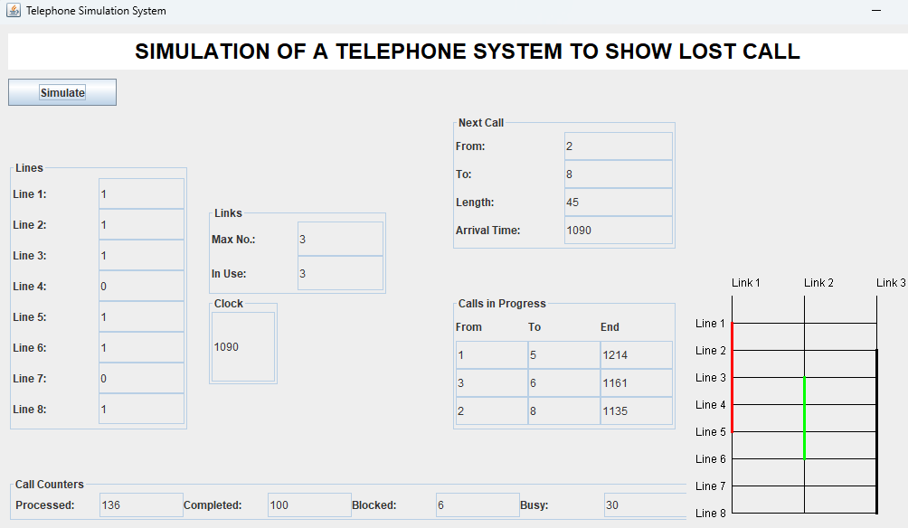
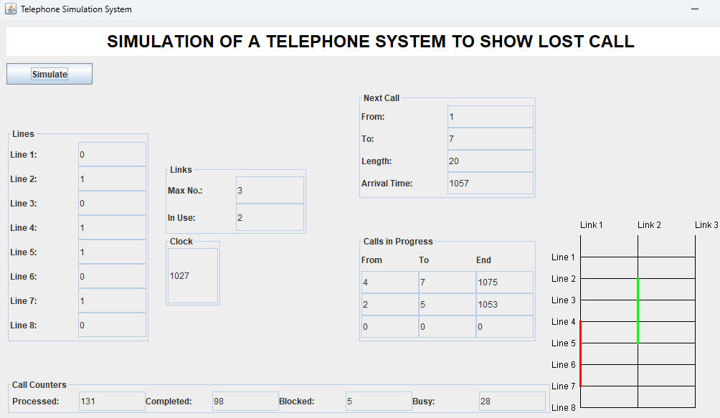
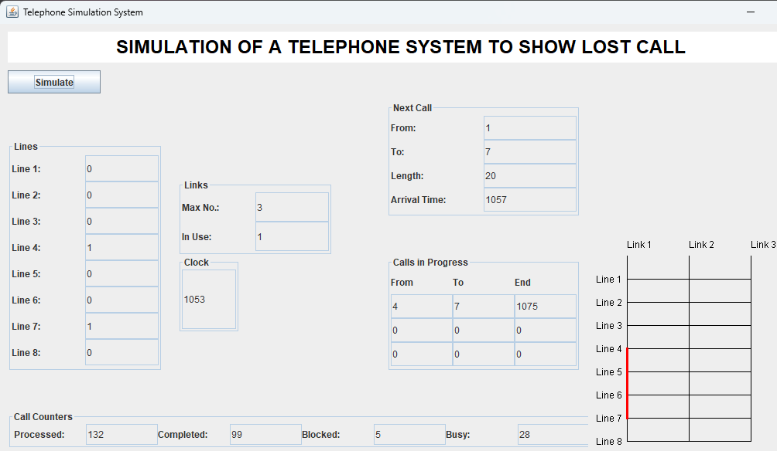

DELAYED CALL SYSTEM
A delayed call refers to a situation where the completion of a call is postponed or delayed due to various factors, often because of network congestion, resource limitations, or queuing. In telecommunications systems, a delayed call typically occurs when the system cannot immediately connect a call but allows the call to be queued or reattempted at a later time. This situation contrasts with blocked calls (where the call is rejected outright) or busy calls (where the called party is occupied).
Characteristics of a Delayed Call:
Queueing Mechanism: In systems that allow delayed calls, incoming calls can be placed in a queue if all available channels or resources are busy. Once a channel becomes free, the call is processed and connected.
Temporary Holding: The caller or request is temporarily held, usually for a brief period, until the resources become available. The call is not lost, but it has to wait before being connected.
Network or System Congestion: Delayed calls often happen during periods of high traffic when the system is overwhelmed with requests. For example, during peak hours, if more calls are made than there are available channels, some calls may be delayed and queued until a channel opens up.
Call Back or Retry Mechanism: In some systems, if a call cannot be completed immediately, the system may automatically retry the call after a short delay, or the user may choose to call back after some time.

import javax.swing.*;
import java.awt.*;
import java.util.*;
import java.awt.image.BufferedImage;
import javax.imageio.ImageIO;
import java.io.File;
import java.io.IOException;
import java.lang.Object;
import java.util.List;
class DelayCall extends JFrame {
private JTextField nextFromField, nextToField, nextLengthField, nextArrivalTimeField;
private JTextField lineField1, lineField2, lineField3, lineField4, lineField5, lineField6,
lineField7, lineField8;
private JTextField clockField, processedField, completedField, blockedField, busyField;
private JTextField fromField1, toField1, endField1;
private JTextField fromField2, toField2, endField2;
private JTextField fromField3, toField3, endField3, inUseField;
private JTextField delayedFromField, delayedToField, delayedLengthField;
private Queue<Call> callQueue = new PriorityQueue<>(Comparator.comparingInt(c ->
c.arrivalTime));
private List<Call> delayedCalls = new ArrayList<>();
private LinksPanel linksPanel;
public DelayCall() {
setTitle("Delayed Call Simulation");
setSize(1800, 600);
setDefaultCloseOperation(JFrame.EXIT_ON_CLOSE);
setLayout(null);
initializeUI();
initializeCallQueue();
}
private void initializeUI() {
JLabel headerLabel = new JLabel(" SIMULATION OF A TELEPHONE SYSTEM TO SHOW DELAYED CALL SYSTEM");
headerLabel.setFont(new Font("Arial", Font.BOLD, 24));
headerLabel.setForeground(Color.BLACK);
headerLabel.setOpaque(true);
headerLabel.setBackground(Color.WHITE);
headerLabel.setHorizontalAlignment(SwingConstants.LEFT);
headerLabel.setBounds(10, 10, 1200, 40);
add(headerLabel);
JPanel buttonsPanel = new JPanel(new FlowLayout(FlowLayout.LEFT));
buttonsPanel.setBounds(10, 50, 760, 40);
JButton clickHereButton = new JButton("Simulate");
clickHereButton.addActionListener(e -> handleNextStateButtonClick());
buttonsPanel.add(clickHereButton);
add(buttonsPanel);
JPanel nextCallPanel = new JPanel(new GridLayout(4, 2));
nextCallPanel.setBorder(BorderFactory.createTitledBorder("Next Call"));
nextCallPanel.add(new JLabel("From:"));
nextFromField = new JTextField("1", 5);
nextCallPanel.add(nextFromField);
nextCallPanel.add(new JLabel("To:"));
nextToField = new JTextField("7", 5);
nextCallPanel.add(nextToField);
nextCallPanel.add(new JLabel("Length:"));
nextLengthField = new JTextField("20", 5);
nextCallPanel.add(nextLengthField);
nextCallPanel.add(new JLabel("Arrival Time:"));
nextArrivalTimeField = new JTextField("1057", 5);
nextCallPanel.add(nextArrivalTimeField);
nextCallPanel.setBounds(500, 100, 250, 150); // Moved upward
add(nextCallPanel);
JPanel delayedCallPanel = new JPanel(new GridLayout(4, 2));
delayedCallPanel.setBorder(BorderFactory.createTitledBorder("Delayed Call"));
delayedCallPanel.add(new JLabel("From:"));
delayedFromField = new JTextField("0", 5);
delayedCallPanel.add(delayedFromField);
delayedCallPanel.add(new JLabel("To:"));
delayedToField = new JTextField("0", 5);
delayedCallPanel.add(delayedToField);
delayedCallPanel.add(new JLabel("Length:"));
delayedLengthField = new JTextField("0", 5);
delayedLengthField.setEditable(false);
delayedCallPanel.add(delayedLengthField);
delayedCallPanel.setBounds(500, 260, 250, 150); // Moved upward
add(delayedCallPanel);
JPanel callsInProgressPanel = new JPanel(new GridLayout(4, 3));
callsInProgressPanel.setBorder(BorderFactory.createTitledBorder("Calls in Progress"));
callsInProgressPanel.add(new JLabel("From"));
callsInProgressPanel.add(new JLabel("To"));
callsInProgressPanel.add(new JLabel("End"));
fromField1 = new JTextField("4", 5);
toField1 = new JTextField("7", 5);
endField1 = new JTextField("1075", 5);
callsInProgressPanel.add(fromField1);
callsInProgressPanel.add(toField1);
callsInProgressPanel.add(endField1);
fromField2 = new JTextField("2", 5);
toField2 = new JTextField("5", 5);
endField2 = new JTextField("1053", 5);
callsInProgressPanel.add(fromField2);
callsInProgressPanel.add(toField2);
callsInProgressPanel.add(endField2);
fromField3 = new JTextField("0", 5);
toField3 = new JTextField("0", 5);
endField3 = new JTextField("0", 5);
callsInProgressPanel.add(fromField3);
callsInProgressPanel.add(toField3);
callsInProgressPanel.add(endField3);
callsInProgressPanel.setBounds(500, 420, 250, 150);
add(callsInProgressPanel);
JPanel clockPanel = new JPanel(new BorderLayout());
clockPanel.setBorder(BorderFactory.createTitledBorder("Clock"));
clockField = new JTextField("1053", 5);
clockPanel.add(clockField, BorderLayout.CENTER);
clockPanel.setBounds(350, 200, 80, 90);
add(clockPanel);
JPanel linesPanel = new JPanel(new GridLayout(8, 2));
linesPanel.setBorder(BorderFactory.createTitledBorder("Lines"));
lineField1 = new JTextField("0", 1);
lineField1.setEditable(false);
linesPanel.add(new JLabel("Line 1:"));
linesPanel.add(lineField1);
lineField2 = new JTextField("1", 1);
lineField2.setEditable(false);
linesPanel.add(new JLabel("Line 2:"));
linesPanel.add(lineField2);
lineField3 = new JTextField("0", 1);
lineField3.setEditable(false);
linesPanel.add(new JLabel("Line 3:"));
linesPanel.add(lineField3);
lineField4 = new JTextField("1", 1);
lineField4.setEditable(false);
linesPanel.add(new JLabel("Line 4:"));
linesPanel.add(lineField4);
lineField5 = new JTextField("1", 1);
lineField5.setEditable(false);
linesPanel.add(new JLabel("Line 5:"));
linesPanel.add(lineField5);
lineField6 = new JTextField("0", 1);
lineField6.setEditable(false);
linesPanel.add(new JLabel("Line 6:"));
linesPanel.add(lineField6);
lineField7 = new JTextField("1", 1);
lineField7.setEditable(false);
linesPanel.add(new JLabel("Line 7:"));
linesPanel.add(lineField7);
lineField8 = new JTextField("0", 1);
lineField8.setEditable(false);
linesPanel.add(new JLabel("Line 8:"));
linesPanel.add(lineField8);
linesPanel.setBounds(10, 100, 150, 400);
add(linesPanel);
JPanel linksPanel = new JPanel(new GridLayout(2, 2));
linksPanel.setBorder(BorderFactory.createTitledBorder("Links"));
linksPanel.add(new JLabel("Max No.:"));
JTextField maxNoField = new JTextField("3", 1);
maxNoField.setEditable(false);
linksPanel.add(maxNoField);
linksPanel.add(new JLabel("In Use:"));
inUseField = new JTextField("1", 1);
linksPanel.add(inUseField);
linksPanel.setBounds(250, 300, 200, 100); // Adjusted position below the clock panel
add(linksPanel);
JPanel callCountersPanel = new JPanel(new GridLayout(1, 8));
callCountersPanel.setBorder(BorderFactory.createTitledBorder("Call Counters"));
JLabel processedLabel = new JLabel("Processed:");
processedField = new JTextField("131", 5);
callCountersPanel.add(processedLabel);
callCountersPanel.add(processedField);
JLabel completedLabel = new JLabel("Completed:");
completedField = new JTextField("98", 5);
callCountersPanel.add(completedLabel);
callCountersPanel.add(completedField);
JLabel blockedLabel = new JLabel("Blocked:");
blockedField = new JTextField("5", 5);
callCountersPanel.add(blockedLabel);
callCountersPanel.add(blockedField);
JLabel busyLabel = new JLabel("Busy:");
busyField = new JTextField("28", 5);
callCountersPanel.add(busyLabel);
callCountersPanel.add(busyField);
callCountersPanel.setBounds(10, 580, 760, 50);
add(callCountersPanel);
linksPanel = new LinksPanel();
linksPanel.setBounds(760, 280, 280, 540); // Adjusted position
add(linksPanel);
setVisible(true);
}
private void initializeCallQueue() {
callQueue.add(new Call(1, 7, 1057, 20)); // Initial call
callQueue.add(new Call(3, 6, 1063, 45)); // Next call
refreshNextCallPanel();
}
private void handleNextStateButtonClick() {
checkForCompletedCalls();
if (!callQueue.isEmpty()) {
Call nextCall = callQueue.peek();
int nextArrivalTime = nextCall.arrivalTime;
int currentTime = Integer.parseInt(clockField.getText());
if (nextArrivalTime <= currentTime) {
callQueue.poll(); // Remove the call from the queue
processCall(nextCall);
} else {
int nextEndTime = getNextEndTime();
if (nextEndTime < nextArrivalTime) {
clockField.setText(String.valueOf(nextEndTime));
checkForCompletedCalls();
} else {
clockField.setText(String.valueOf(nextArrivalTime));
processCall(nextCall);
}
}
} else {
JOptionPane.showMessageDialog(this, "No more calls in the queue.");
}
}
private int getNextEndTime() {
int nextEndTime = Integer.MAX_VALUE;
if (!endField1.getText().equals("0")) {
nextEndTime = Math.min(nextEndTime, Integer.parseInt(endField1.getText()));
}
if (!endField2.getText().equals("0")) {
nextEndTime = Math.min(nextEndTime, Integer.parseInt(endField2.getText()));
}
if (!endField3.getText().equals("0")) {
nextEndTime = Math.min(nextEndTime, Integer.parseInt(endField3.getText()));
}
return nextEndTime;
}
private void checkForCompletedCalls() {
int currentTime = Integer.parseInt(clockField.getText());
if (!endField1.getText().equals("0") && Integer.parseInt(endField1.getText()) <=
currentTime) {
completeCall(fromField1, toField1, endField1);
}
if (!endField2.getText().equals("0") && Integer.parseInt(endField2.getText()) <=
currentTime) {
completeCall(fromField2, toField2, endField2);
}
if (!endField3.getText().equals("0") && Integer.parseInt(endField3.getText()) <=
currentTime) {
completeCall(fromField3, toField3, endField3);
}
processDelayedCalls();
}
private void completeCall(JTextField fromField, JTextField toField, JTextField endField) {
setLineStatus(Integer.parseInt(fromField.getText()), "0");
setLineStatus(Integer.parseInt(toField.getText()), "0");
inUseField.setText(String.valueOf(Integer.parseInt(inUseField.getText()) - 1));
completedField.setText(String.valueOf(Integer.parseInt(completedField.getText()) + 1));
updateProcessedField();
if (!delayedCalls.isEmpty()) {
Call delayedCall = delayedCalls.remove(0);
fromField.setText(String.valueOf(delayedCall.from));
toField.setText(String.valueOf(delayedCall.to));
endField.setText(String.valueOf(Integer.parseInt(clockField.getText()) +
delayedCall.length));
setLineStatus(delayedCall.from, "1");
setLineStatus(delayedCall.to, "1");
inUseField.setText(String.valueOf(Integer.parseInt(inUseField.getText()) + 1));
delayedFromField.setText("0");
delayedToField.setText("0");
delayedLengthField.setText("0");
} else {
fromField.setText("0");
toField.setText("0");
endField.setText("0");
}
linksPanel.repaint();
refreshNextCallPanel();
}
private void processCall(Call call) {
nextFromField.setText(String.valueOf(call.from));
nextToField.setText(String.valueOf(call.to));
nextLengthField.setText(String.valueOf(call.length));
nextArrivalTimeField.setText(String.valueOf(call.arrivalTime));
clockField.setText(String.valueOf(call.arrivalTime));
if (!fromField1.getText().equals("0") && !fromField2.getText().equals("0") &&
!fromField3.getText().equals("0")) {
blockedField.setText(String.valueOf(Integer.parseInt(blockedField.getText()) + 1));
updateProcessedField(); // Update processed field
clearNextCallPanel();
return;
}
if (isLineFree(call.from) && isLineFree(call.to) &&
Integer.parseInt(inUseField.getText()) < 3) {
connectCall(call);
} else {
delayedCalls.add(call);
delayedFromField.setText(String.valueOf(call.from));
delayedToField.setText(String.valueOf(call.to));
delayedLengthField.setText(String.valueOf(call.length));
busyField.setText(String.valueOf(Integer.parseInt(busyField.getText()) + 1));
}
updateProcessedField();
clearNextCallPanel();
linksPanel.repaint();
}
private void clearNextCallPanel() {
nextFromField.setText("");
nextToField.setText("");
nextLengthField.setText("");
nextArrivalTimeField.setText("");
}
private void processDelayedCalls() {
}
private void connectCall(Call call) {
setLineStatus(call.from, "1");
setLineStatus(call.to, "1");
inUseField.setText(String.valueOf(Integer.parseInt(inUseField.getText()) + 1));
if (fromField1.getText().equals("0")) {
fromField1.setText(String.valueOf(call.from));
toField1.setText(String.valueOf(call.to));
endField1.setText(String.valueOf(call.arrivalTime + call.length));
} else if (fromField2.getText().equals("0")) {
fromField2.setText(String.valueOf(call.from));
toField2.setText(String.valueOf(call.to));
endField2.setText(String.valueOf(call.arrivalTime + call.length));
} else if (fromField3.getText().equals("0")) {
fromField3.setText(String.valueOf(call.from));
toField3.setText(String.valueOf(call.to));
endField3.setText(String.valueOf(call.arrivalTime + call.length));
}
refreshNextCallPanel();
}
private void refreshNextCallPanel() {
if (!callQueue.isEmpty()) {
Call nextCall = callQueue.peek();
nextFromField.setText(String.valueOf(nextCall.from));
nextToField.setText(String.valueOf(nextCall.to));
nextLengthField.setText(String.valueOf(nextCall.length));
nextArrivalTimeField.setText(String.valueOf(nextCall.arrivalTime));
} else {
clearNextCallPanel();
}
}
private void updateProcessedField() {
int processed = Integer.parseInt(completedField.getText()) +
Integer.parseInt(busyField.getText()) + Integer.parseInt(blockedField.getText());
processedField.setText(String.valueOf(processed));
}
private boolean isLineFree(int line) {
switch (line) {
case 1:
return lineField1.getText().equals("0");
case 2:
return lineField2.getText().equals("0");
case 3:
return lineField3.getText().equals("0");
case 4:
return lineField4.getText().equals("0");
case 5:
return lineField5.getText().equals("0");
case 6:
return lineField6.getText().equals("0");
case 7:
return lineField7.getText().equals("0");
case 8:
return lineField8.getText().equals("0");
default:
return false;}}
private void setLineStatus(int line, String status) {
switch (line) {
case 1:
lineField1.setText(status);
break;
case 2:
lineField2.setText(status);
break;
case 3:
lineField3.setText(status);
break;
case 4:
lineField4.setText(status);
break;
case 5:
lineField5.setText(status);
break;
case 6:
lineField6.setText(status);
break;
case 7:
lineField7.setText(status);
break;
case 8:
lineField8.setText(status);
break;}}
public static void main(String[] args) {
SwingUtilities.invokeLater(DelayCall::new);}
private class Call {
int from, to, arrivalTime, length;
Call(int from, int to, int arrivalTime, int length) {
this.from = from;
this.to = to;
this.arrivalTime = arrivalTime;
this.length = length;
}}
private class LinksPanel extends JPanel {
private BufferedImage telephoneImage;
public LinksPanel() {
try {
telephoneImage = ImageIO.read(new File("telephone.png"));
} catch (IOException e) {
e.printStackTrace();
}
}
@Override
protected void paintComponent(Graphics g) {
super.paintComponent(g);
Graphics2D g2d = (Graphics2D) g;
int startX = 50;
int startY = 20;
int lineSpacing = 30;
int linkWidth = 80;
g2d.setColor(Color.BLACK);
g2d.drawString("Link 1", startX, startY - 10);
g2d.drawString("Link 2", startX + linkWidth, startY - 10);
g2d.drawString("Link 3", startX + 2 * linkWidth, startY - 10);
for (int i = 1; i <= 8; i++) {
g2d.drawLine(startX, startY + i * lineSpacing, startX + 2 * linkWidth, startY + i *
lineSpacing);
g2d.drawString("Line " + i, startX - 40, startY + i * lineSpacing + 5);
}
if (telephoneImage != null) {
for (int i = 1; i <= 8; i++) {
g2d.drawImage(telephoneImage, startX -50, startY + i * lineSpacing - 10, 10, 10,
this);
}
}
g2d.drawLine(startX, startY, startX, startY + 8 * lineSpacing);
g2d.drawLine(startX + linkWidth, startY, startX + linkWidth, startY + 8 * lineSpacing);
g2d.drawLine(startX + 2 * linkWidth, startY, startX + 2 * linkWidth, startY + 8 *
lineSpacing);
g2d.setStroke(new BasicStroke(3));
if (!fromField1.getText().equals("0")) {
int from = Integer.parseInt(fromField1.getText());
int to = Integer.parseInt(toField1.getText());
g2d.setColor(Color.RED);
g2d.drawLine(startX, startY + from * lineSpacing, startX, startY + to *
lineSpacing);
}
if (!fromField2.getText().equals("0")) {
int from = Integer.parseInt(fromField2.getText());
int to = Integer.parseInt(toField2.getText());
g2d.setColor(Color.GREEN);
g2d.drawLine(startX + linkWidth, startY + from * lineSpacing, startX + linkWidth,
startY + to * lineSpacing);
}
if (!fromField3.getText().equals("0")) {
int from = Integer.parseInt(fromField3.getText());
int to = Integer.parseInt(toField3.getText());
g2d.setColor(Color.BLUE);
g2d.drawLine(startX + 2 * linkWidth, startY + from * lineSpacing, startX + 2 *
linkWidth, startY + to * lineSpacing);
}
}
}
}

OUTPUT
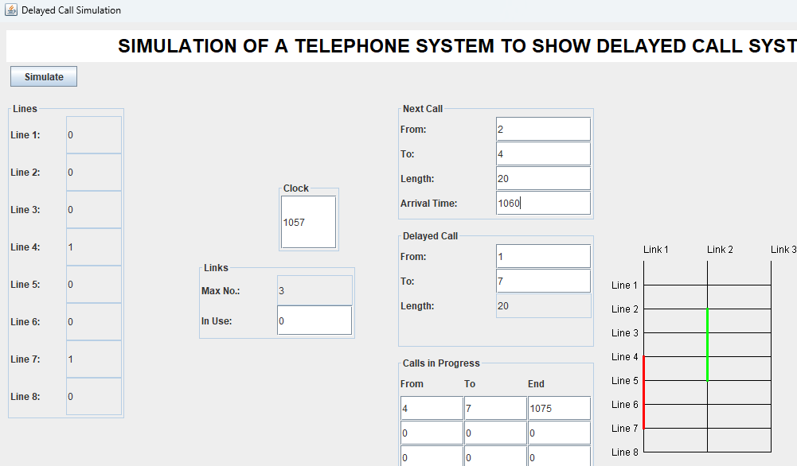

CONCLUSION

The Telephone Simulation System successfully demonstrates the principles of call management and resource allocation in a telecommunication network. By simulating various operations such as call initiation, progress, and completion, the system provides valuable insights into network resource utilization and efficiency. It also highlights the importance of managing limited resources effectively, addressing issues like blocked calls and busy lines. Overall, this project offers a practical understanding of telecommunication systems and can serve as a foundation for further research and development in network simulation and optimization.

